ASAS-SN Plugin for VStar
Description: This plugin allows you to open text files in the formats of the All-Sky Automated Survey for Supernovae (ASAS-SN).
Data files can be generated using the ASAS-SN Sky Patrol website or downloaded from the ASAS-SN Photometry Database or ASAS-SN Variable Stars Database. The format of precomputed data files, loaded from ASAS-SN Photometry and ASAS-SN Variable Stars databases, differs from one generated by the Sky Patrol. The plugin loads files of both formats.

ASAS-SN Sky Patrol data
ASAS-SN Sky Patrol data are computed in real-time using aperture photometry for a point on the celestial sphere for which ASAS-SN images exist. Go to Sky Patrol website, enter coordinates of a target and number of days to go back, then press [Compute]
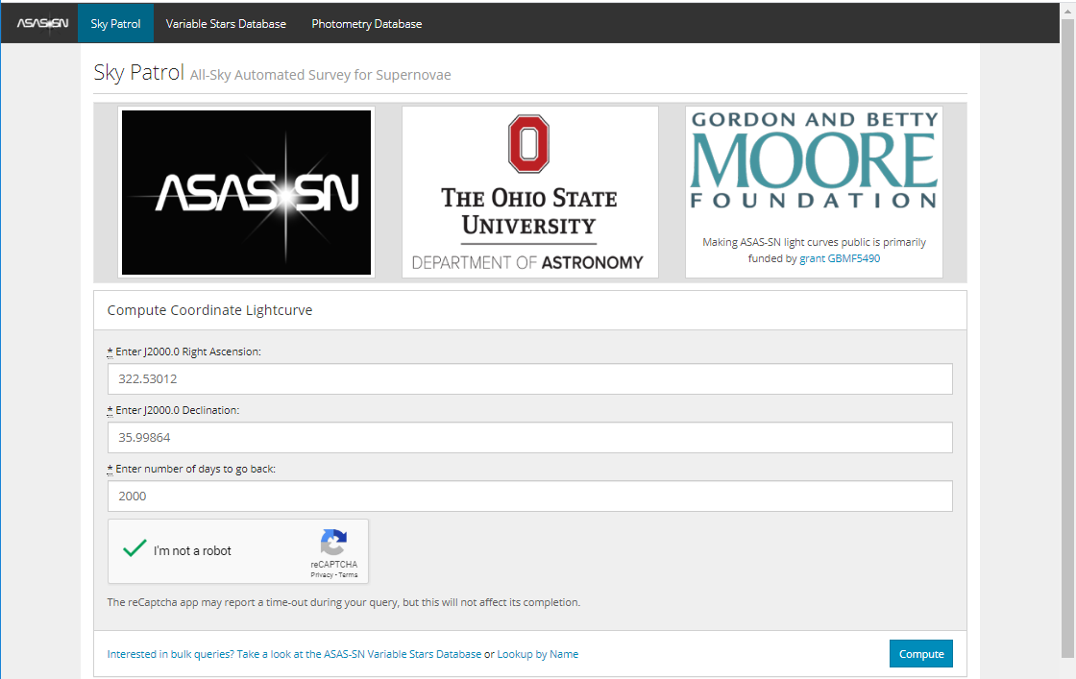

The calculation process may take a while. When calculations succeed, you will be redirected to the result page.
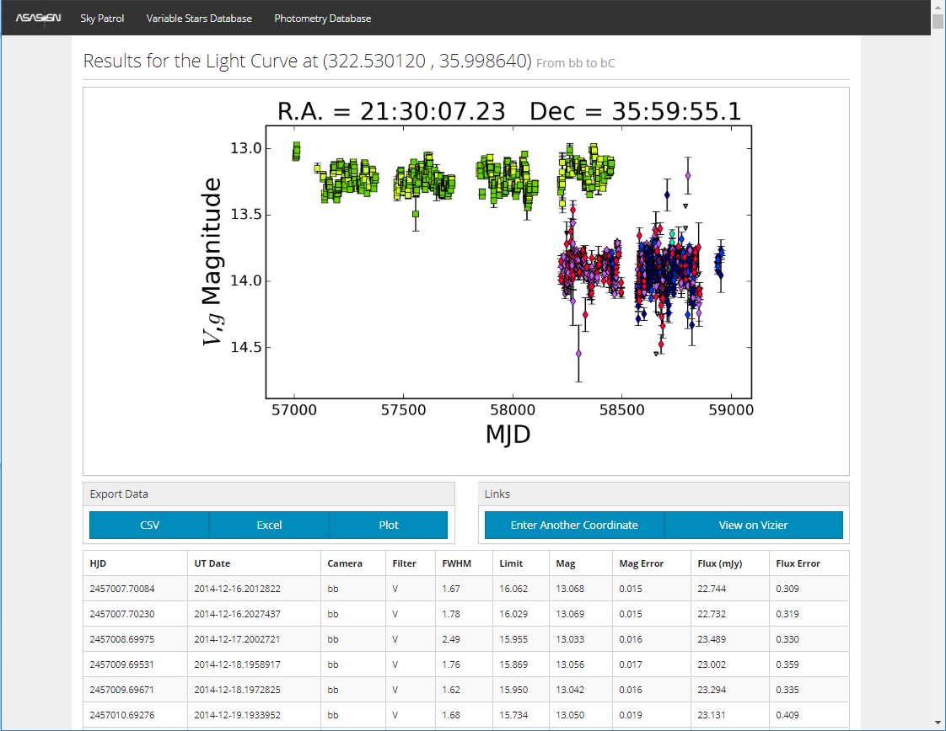

Press [CSV] button under “Export Data” and save CSV-file to disk. The file contains data for V and g bands, as it is seen from the preview plot.
From VStar (version 2.21+), select [New Star from File...] from the [File] menu and then select “ASAS-SN” in the “Source” dropdown list. Go to the location of the saved file and open it.
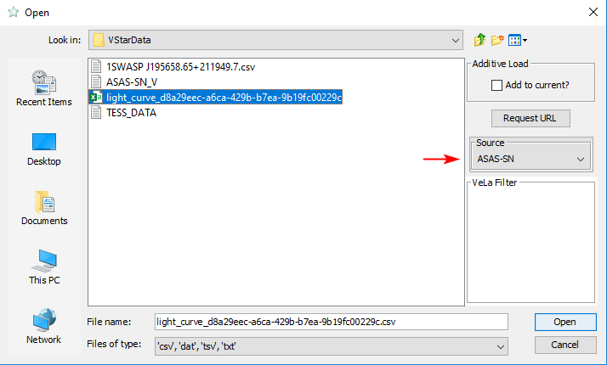

The following dialog will appear:
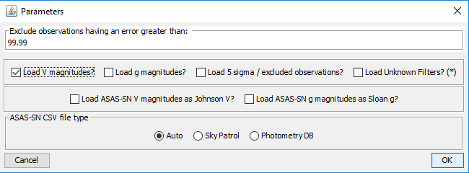
Currently, ASAS-SN light curves can contain data for V and g bands. Some observations in a file can be marked as unreliable (“5 sigma/excluded observations”), they can be excluded by unchecking the corresponding checkbox. A user can limit the maximum allowed uncertainty (“Exclude observations having an error greater than” field). “ASAS-SN CSV file type” option should be set to “Auto” in most cases.
Select the data you need (let’s assume you have selected data for V band only) and press OK. VStar will show you a light curve:
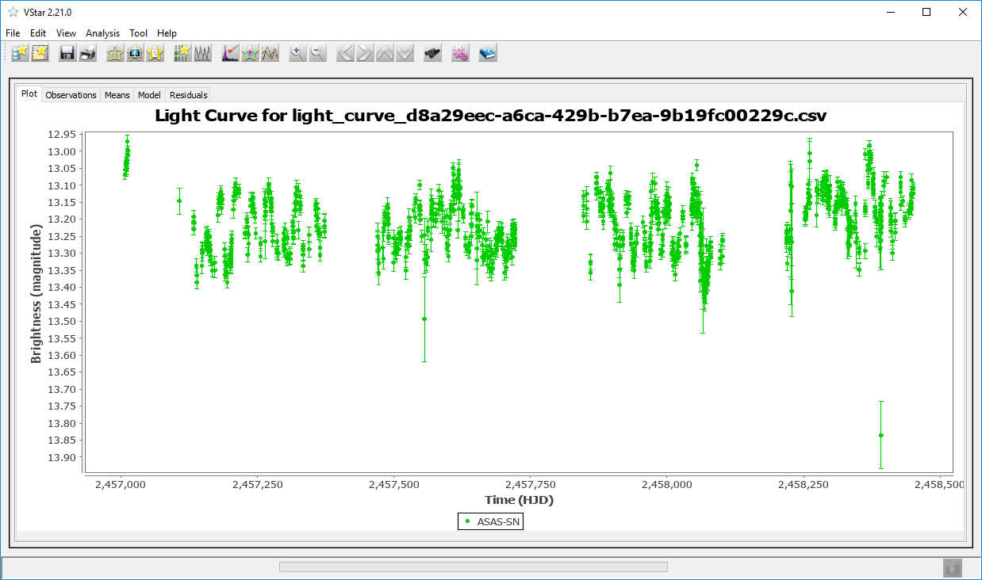

Precomputed ASAS-SN Light Curves
Other sources for ASAS-SN light curves are ASAS-SN Photometry Database and ASAS-SN Variable Stars Database. Those databases contain ready-to-use light curves in a format that differs from one produced by Sky Patrol. The plugin loads files of both formats.
To download a light curve, go to one of the databases and enter coordinates and search radius (for both databases) or ASAS-SN variable name (for the Variable Star Database). If precomputed curves exist, they will be listed. Do not load the data via [Download CSV Dataset] button (the format is currently not supported by the plugin). Instead, click on one of the curves’ IDs.
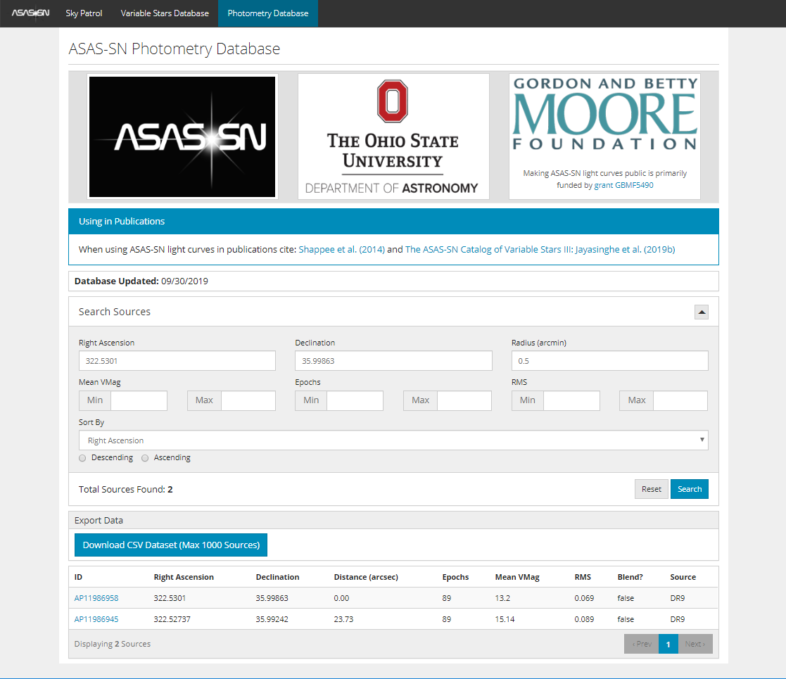

You will see a new window with a preview plot. Click on the [CSV] button under “Export Data” to download a file. This file can be opened by the plugin the same way as described above.
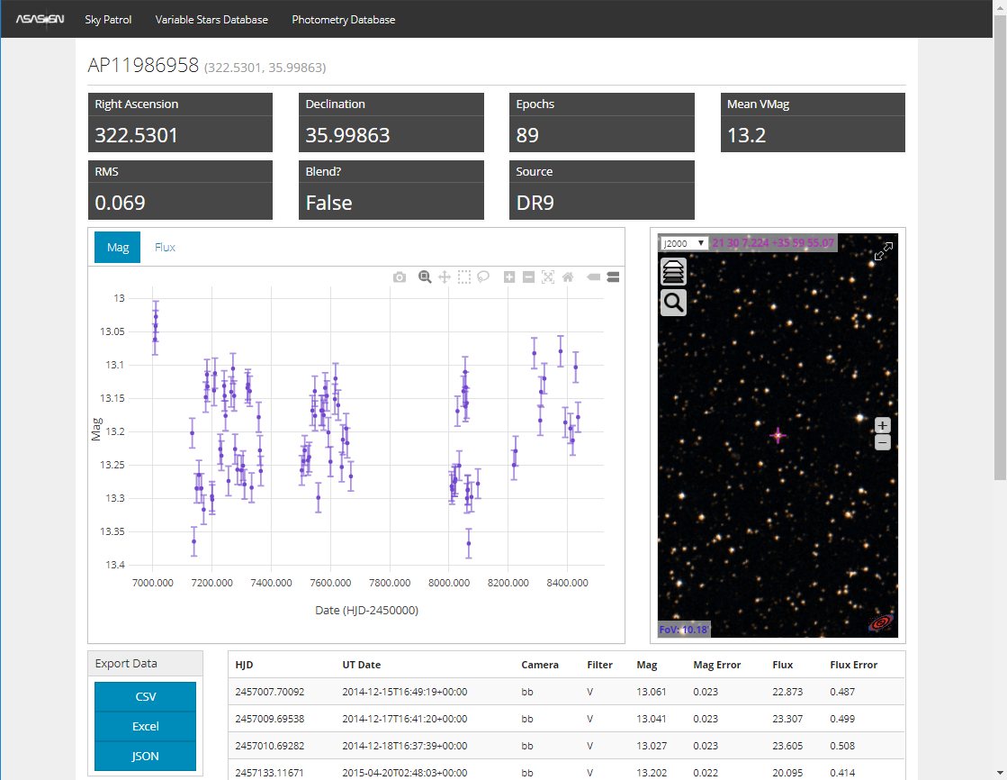

Maksym Pyatnytskyy (PMAK)
Rev B
2020-04-26
Revision History
Rev | Date | Description
B | 2020-04-26 | Open Dialog image added
A | 2020-04-17 | Initial Release

